DEVCLUB PART 2

DESIGN DOCUMENTATION

* I have redesigned the website https://www.art.yale.edu .
* The purpose of doing this was the bad design for the website.
* The website had more text than necessary, and was barely following any material-UI guidelines. There was a mismatch of colours making it look worse.
* My website design is very subtle and user friendly. It is very compact and easy for the user to navigate through. Moreover, it follows a lot of the material-UI guidelines, and uses very few colours making it look simple and beautiful at the same time.
* For example, my navigation bar, is much better than the original website’s, look wise, as well as ease of navigation wise.
* The Yale logo on top also has a beautiful continually changing background with each page swap.
* After all, it is an art school’s website, and should be looking much better than what it does now.
* One of several websites from where I took motivation for my design is [www.wix.com](http://www.wix.com) .
* Attached below are my sketches which I used, to put my ideas on paper before I started designing the website:
* 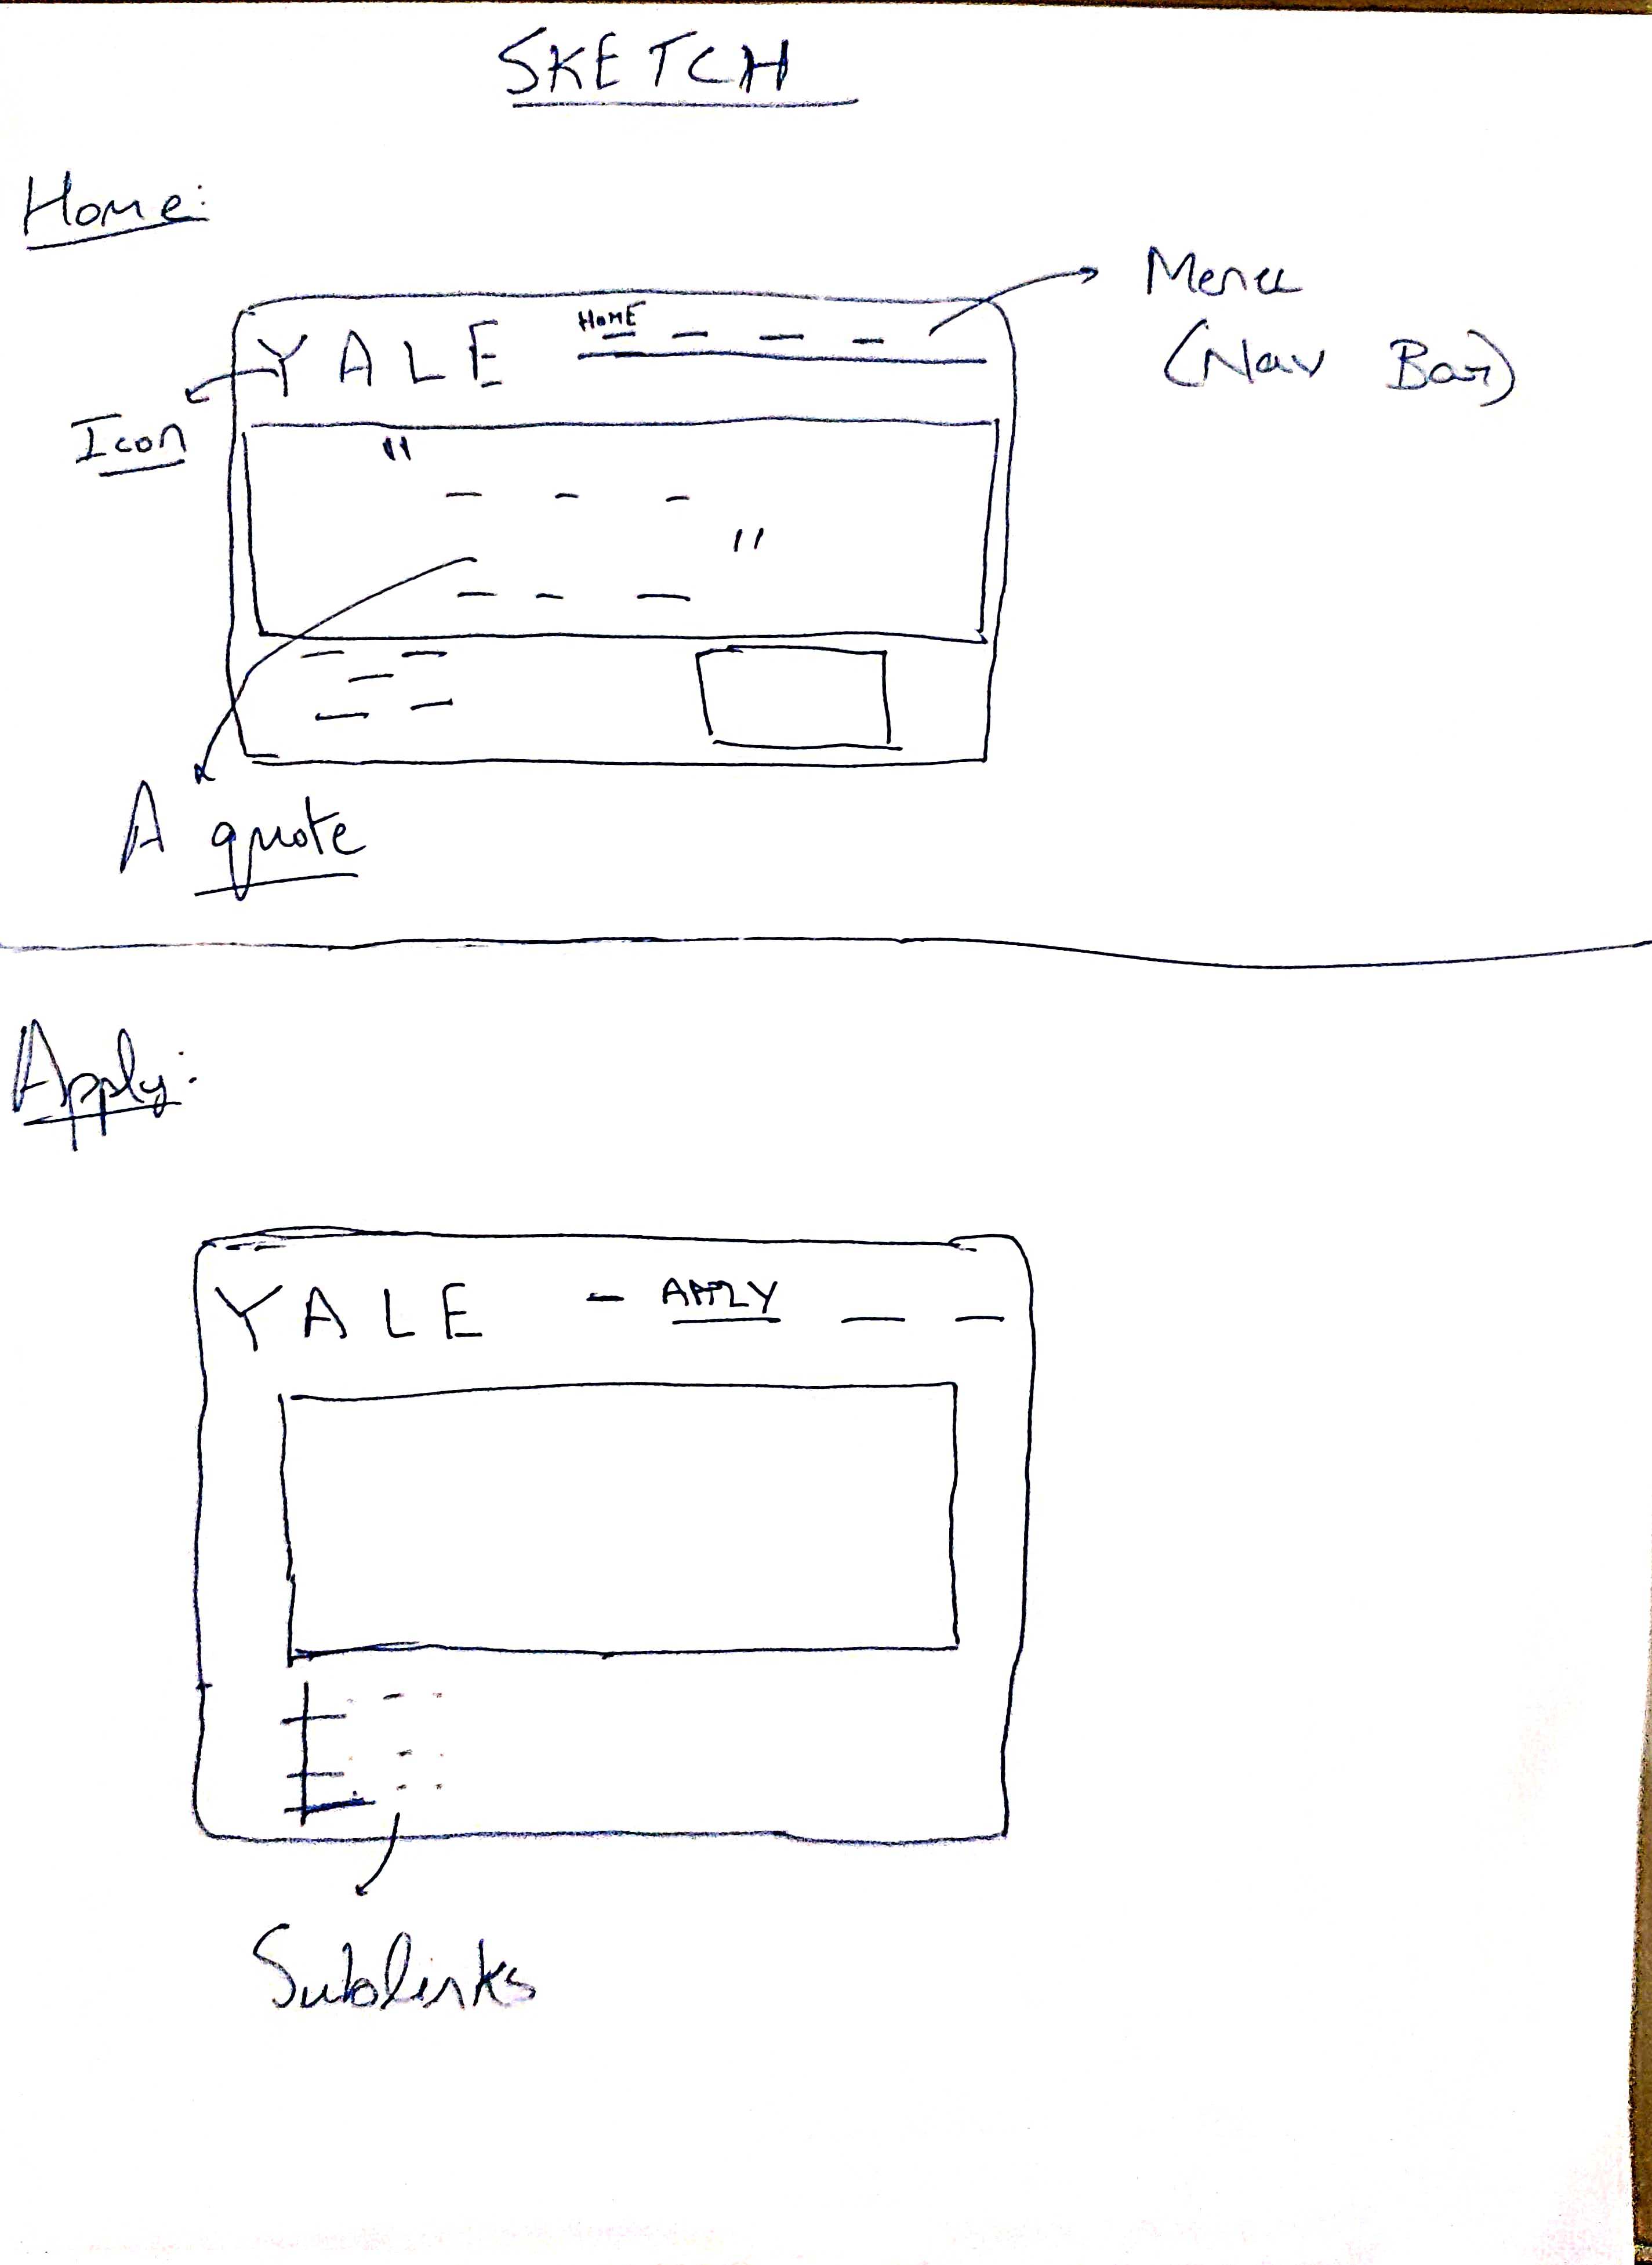
* 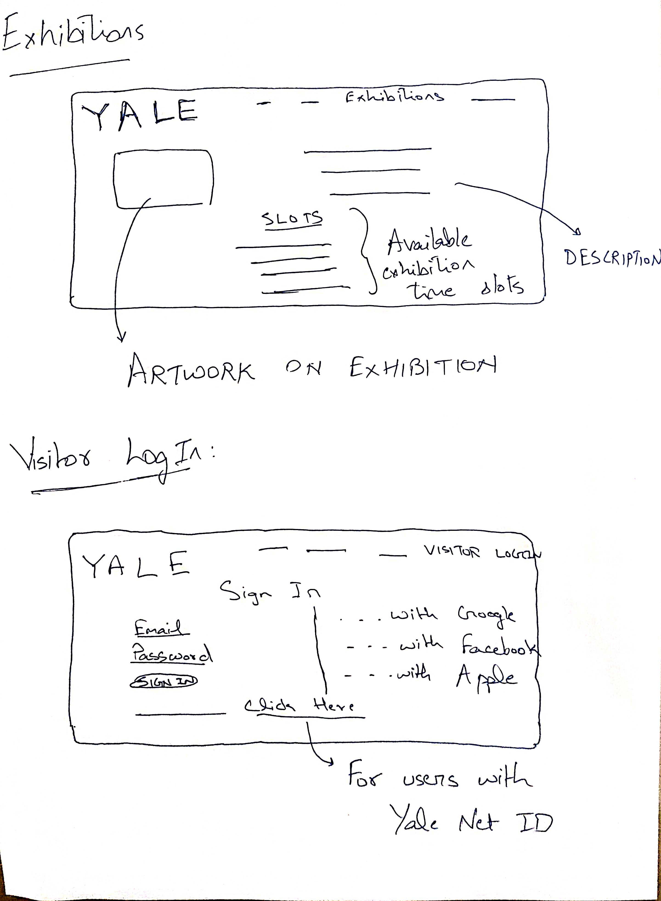
* Using the above sketches, I was able to finally complete my website
* One of the few challenges I faced was: On some pages, a lot of text had to be fit in. This was difficult to do while still maintaining the good look of the page.
* The only downside of this project is that:
  + The website is not very accessible for those with disabilities such as motor disabilities vision impairment.
  + It’s not responsive and the current design is only for Desktops.
* I plan to fix these downsides in the near future and one day, perfect this website.